**Part 6 – Rational Expressions**

Rational = Dividing an integer (whole number) by an integer

**Reduce to lowest terms.**

**Example.** Simplifyby reducing to lowest terms.

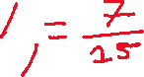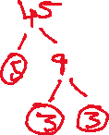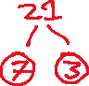

**Example.** Simplify by reducing to lowest terms.

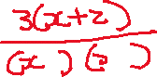

**Multiplying and Dividing**

**Example.** Compute

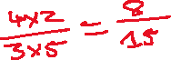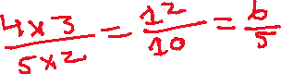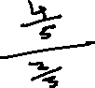

**Example.** Compute

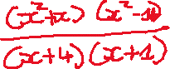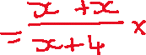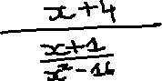

**Adding and Subtracting**

**Example.**  Subtract

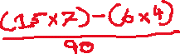

**Example.** Add

